Marketplace Builder Hackathon

Day 2: Planning the Technical Foundation

Student: Sahir Ahmed Sheikh

Timing: Saturday (2 PM - 5 PM)

Roll Number: 00249533

Comforty E-Commerce System Architecture

# System Architecture Overview:

The architecture for the Comforty E-Commerce platform integrates multiple technologies to ensure scalability, user-friendliness, and reliability. Below is a high-level system architecture:

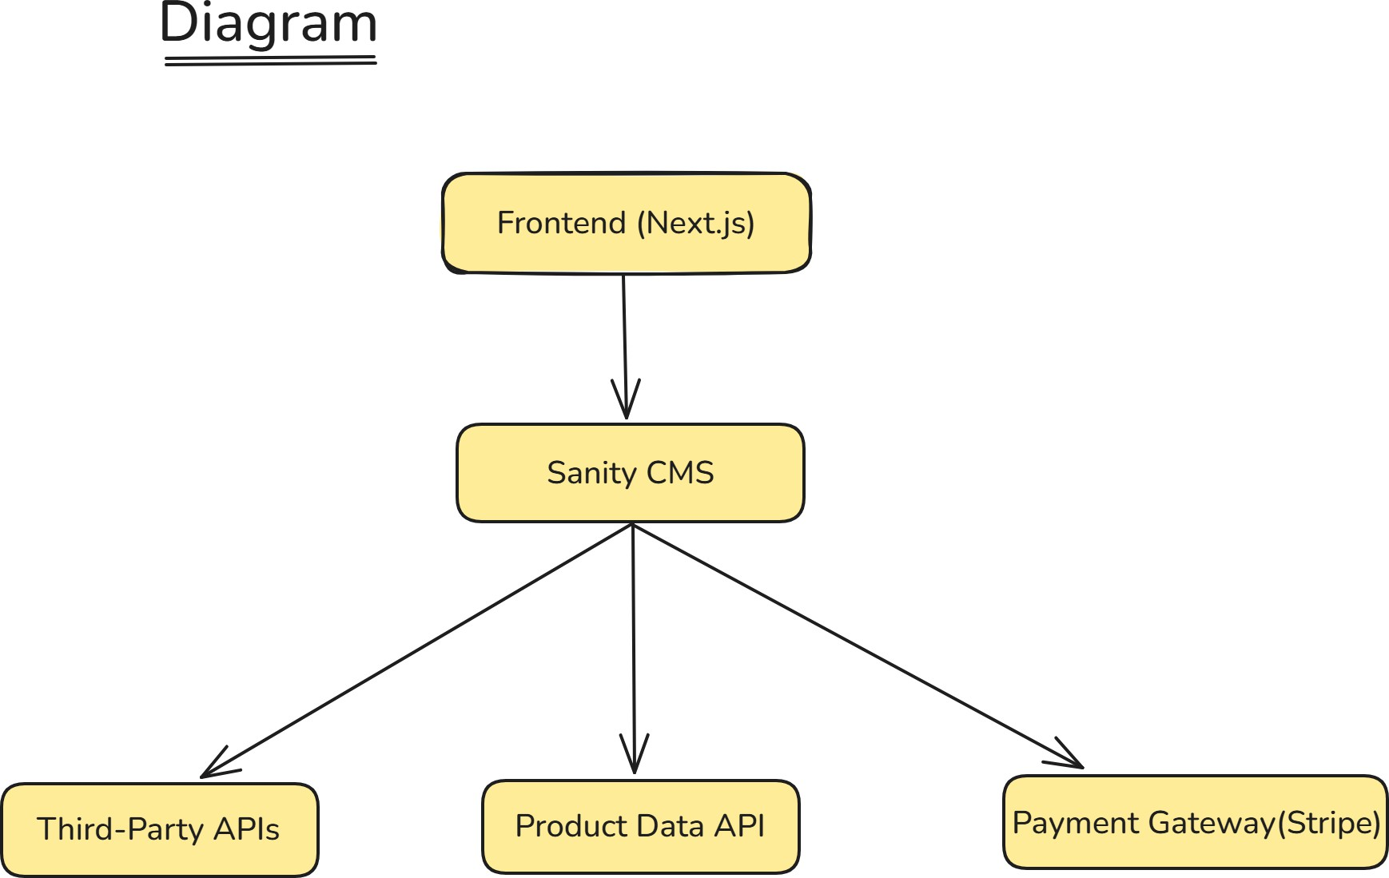

 Components

* + Frontend (Next.js)
    - Dynamic and responsive UI for users.
    - Interacts with backend services to fetch and display data.

 Sanity CMS:

* Acts as the primary backend for managing product data, customer details, and order records.
* Provides APIs for CRUD operations on data.

 Third-Party APIs:

* Shipment tracking to update order delivery status.

 Payment Gateway (Stripe):

* Processes secure transactions.

Key Workflows

1. Product Browsing:
   * User visits the frontend to browse products.
   * Frontend fetches product data via Sanity CMS API.
2. Order Placement:
   * User adds items to the cart and checks out.
   * Order details are stored in Sanity CMS.
3. Shipment Tracking:
   * Order tracking updates are fetched via a third-party API.
4. Payment Processing:
   * Stripe handles secure transactions, and payment confirmation is sent to Sanity CMS.

# API Endpoints:

|  |  |  |  |  |
| --- | --- | --- | --- | --- |
| Endpoint | Method | Purpose | Payload | Response Example |
| /products | GET | Fetch all product details | N/A | { "id": 1,  "name": "Sofa", "price": 1000 } |
| /products/:id | GET | Fetch a specific product | N/A | { "id": 1,  "name": "Sofa", "price": 1000 } |
| /cart | POST | Add item to cart | { "productId": 1, "quantity": 2  } | { "cartId": 123, "status":  "Added" } |
| /checkout | POST | Process checkout | { "cartId": 123, "paymentInfo":  {...}} | { "orderId":  456, "status": "Confirmed" } |
| /shipment | GET | Get shipment tracking info | { "orderId": 456 } | {  "rt``trackingId": "789", "status": "In Transit"} |
| /login | POST | User login | { "email":  "user@exampl e.com",  "password": "..." } | { "token": "jwt_token" } |
| /signup | POST | User registration | { "email":  "user@exampl e.com",  "password": "..." } | { "status":  "Registered" } |

1. Sanity CMS Schema

Product Schema

export default { name: 'product', type: 'document', fields: [

{ name: 'name', type: 'string', title: 'Product Name' },

{ name: 'price', type: 'number', title: 'Price' },

{ name: 'stock', type: 'number', title: 'Stock Level' },

{ name: 'image', type: 'image', title: 'Product Image' }

]

};

Order Schema

export default { name: 'order', type: 'document', fields: [

{ name: 'customer', type: 'reference', to: [{ type: 'customer' }] },

{ name: 'products', type: 'array', of: [{ type: 'product' }] },

{ name: 'status', type: 'string', title: 'Order Status' }

]

};

# Technical Documentation

Workflows

* + Login and Signup:
    - User registers or logs in via the frontend.
    - Details are authenticated and stored in the Sanity CMS.
  + Cart Management:
    - Items added to the cart are tracked using the /cart endpoint.
  + Order Conflrmation:
    - User checks out, and the order is stored in Sanity CMS with payment status.

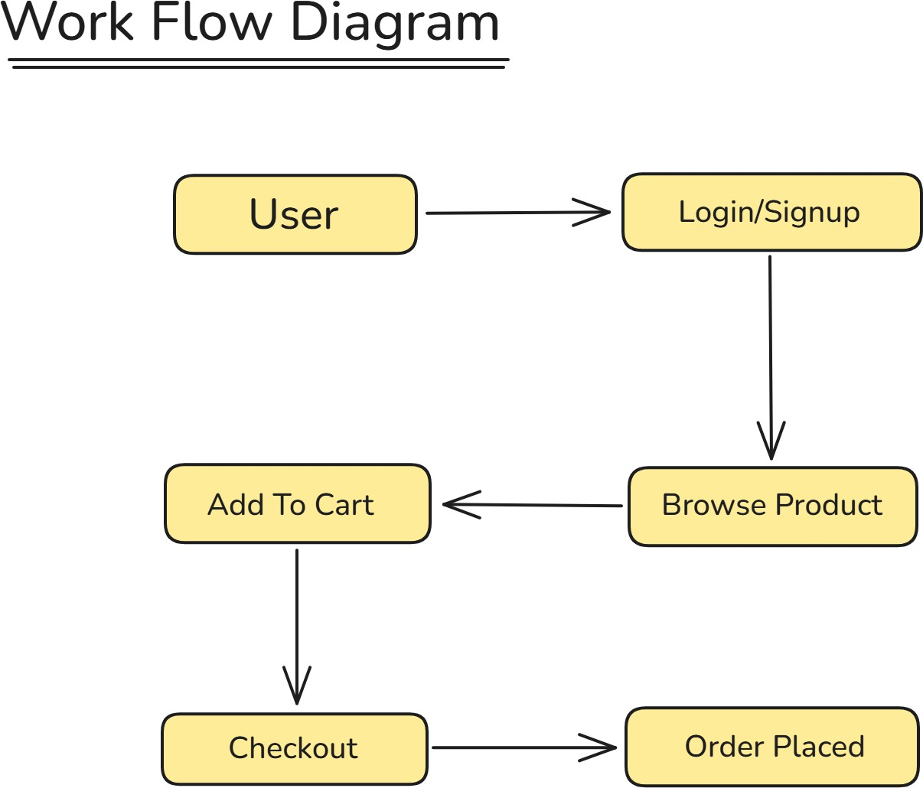

# Submission

The document is structured to reflect the architecture, API specifications, and workflows. The PDF will include:

1. System Architecture Diagram.
2. Detailed API Endpoints.
3. Workflows and Key Features.
4. Sanity CMS Schemas.

# Next Steps

This document ensures the technical foundation is ready for implementation. Following these guidelines will enable smooth development and scalability.